
CIVIL, ENVIRONMENTAL & GEOMATIC ENGINEERING

IVIL, / NO

COURSEWORK COVER SHEET 2021-22

Name of Personal Tutor (for return of coursework after marking):

Date of laboratory (if applicable):

Programme: Year:

Course Module Title & No: CEGE0052

Coursework Title: ASSIGNMENT 5

Name of Staff Member Responsible For Marking:

Submission Deadline: Jan 11, 2023

_________________________________

CEGE

Student Name: ________BORUI WEI_____________________

Student UCL ID Number: ________22134710______________________

Date of submission: ______________JAN 11, 2023_______________

I have read and understand the College’s policy regarding plagiarism
and the submission of coursework.* I confirm that this is my own work except where explicitly indicated in the text.

Signed................................BORUI WEI............................................................

*If you have any questions, please consult the department’s Guidance Notes for Coursework.

MARKER’S COMMENTS:

2D illustration of Duke’s Caravan site database

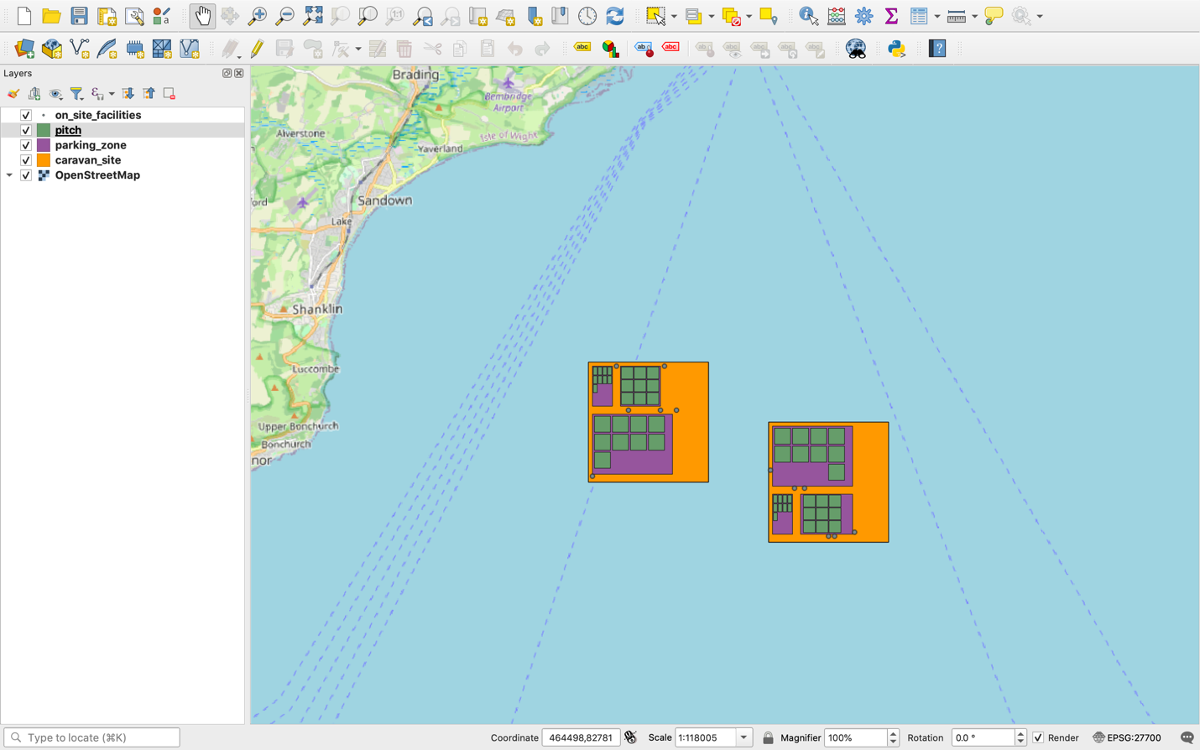

3D illustration of Duke’s Caravan site database

